**How to Avoid Sequoia’s Repetitive Screen Recording Permissions Prompts**

*~/Library/Group Containers/[group.com.apple](http://group.com.apple/" \t "_blank).replayd/*

I just went there and tweaked the *ScreenCaptureApprovals.plist* in BBEdit to look like this:

[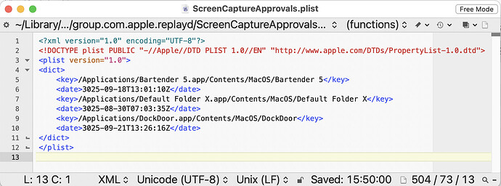](https://talk.tidbits.com/uploads/default/original/2X/c/c12aed0a96bde40d19f34337c3a5be7ce18a9ac4.jpeg)

https://tidbits.com/2024/09/23/how-to-avoid-sequoias-repetitive-screen-recording-permissions-prompts/#:~:text=The%20workaround%20is%20to%20open%20System%20Settings%20%3E%20General%20%3E